Guideline of
Deathbed・Funeral Ceremony Procedure
（A Path to Ascension to Heaven）

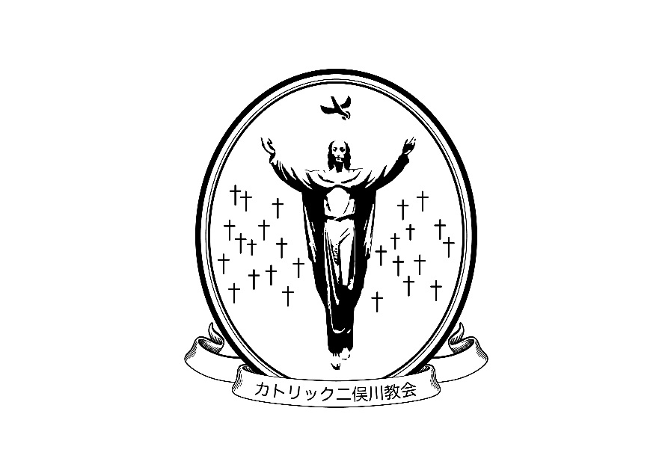

Catholic Church of Futamatagawa

Table of Contents

- Introduction
- Schedule of Funeral Ceremony
- Wake(TSUYA) to Cremation (KASOU)
- Cinerary Process-Laying ashes to rest(NOUKOTSU)
- Mourning Mass
- Funeral Service Company
- Donation to church
- Others

✟ A Guideline for the interment
(Last moment – Funeral Ceremony – Mourning Mass)
１．Introduction
All living things reach to death at some point in time. However, when it arrives, most of the family members do not know what they should do because of confusion caused by deep sorrow. The reason why we prepared the funeral ceremony procedure is for family members to understand the basic process of what to do in the last moment, funeral ceremony and mourning Mass.
２．Schedule of Funeral Ceremony
- Contact the Church
If you have your family, relatives and friends who are suffering from serious disease or dying soon, or has just died, please call the Parish Priest or church office (045-391-6296). If possible, the Parish Priest will go to the hospital with the family’s permission to provide the sacrament of anointing the sick and holy communion.
- In case your family, relatives and friends died in the hospital
- In general, it takes two or three hours to move the remains from the hospital because the doctor has to prepare for the treatment of the remains and provide certification of death. First, please call the church office. (Monday to Saturday, 9:00 – 16:00, Sunday 9:00 – 15:00. If there is no in-charge at that time in the office to pick up the phone, the call will be forwarded to the Parish Priest.)
- You have to move the remains from the hospital to your home or the funeral ceremony place. Please bring the certification of death back home when leaving the hospital.
- The hospital may introduce some funeral services, however, they are unfamiliar with Christian funeral ceremony. First, please keep in touch with the church office so that the office can introduce you a reliable and experienced funeral service. You can select a funeral service who will move the remains from the hospital to your home or the funeral ceremony place and another funeral service to prepare the funeral ceremony. It is necessary to inform clearly the hospital of the name of funeral service you have chosen.
- In case your family, relatives and friends died at home
If you have a family doctor, please ask the doctor to prepare the certificate of death. If you do not have a family doctor, you need to call 119 to have an ambulance or the police come to your home. At the same time, please contact the church office.
- Determination of the funeral ceremony schedule
In general, you will set the date of funeral ceremony next day or day after next day from the date of the death. The funeral schedule should depend on the descendant’s request but 1it needs among the descendants, the church office and the funeral service to arrange the funeral ceremony schedule.
1
- Laying ashes to rest
The date of laying ashes to rest according to the funeral ceremony schedule is decided and the Parish Priest and servants can pray with you at the same time.
The remains should be already in the church within 3 hours before the funeral ceremony.
３．Wake(TSUYA) to Cremation(KASOU)
- Wake (TSUYA)
- Wake (TSUYA) is held by the bereaved family to remember and recollect the memory of the departed. In general, it is held at Church but it is available to have a TSUYA at home.
- Wake is done in accordance with the TSUYA guide prepared by church.
- In case of wake at church, there are internal service to lead communion songs (hymns), an acolyte, an organist, church choir, a guide of TSUYA, receiving flowers and so on. You should ask somebody to check in at the reception desk at the wake, but Church would be able support if you made the request.
- You can have a funeral gathering to thank for mourners at the wake at 2nd floor conference room and have time to cherish the departed good memory. Please communicate the menu of a meal and the drink at funeral gathering with the funeral service company directly. It is available to use the conference room by 9:00 pm but you are not permitted to stay at the church the whole night.

- Funeral and Memorial Ceremony
- This is an important and ceremonious rite to entrust all things to God, take you farewell to your loved ones who have passed away.
- The ceremony will be held in accordance with the Wakes guide prepared by church. You can select favorite sacred songs or verse of Bible for your loved ones, so please contact with the Parish Priest.
- In general, the ceremony will be held as Mass procedure, but you can choose the words of liturgies. Please contact with our Father.
- In the same way of the wake, there are internal services of leading communion songs (hymns), organist, church choir, a guide of TSUYA, receiving flowers and so on. You should ask somebody to check in at the reception desk regarding wake’s internal services, and member of church would be able to help.

- Cremation (KASOU)
- The parish priest or member of church service will accompany with you during the
start of cremation at crematorium.
- In case of cremation at crematorium, you should receive the certification of burial permission and keep it with your loved ones’ bones until placing his/her ashes in tomb.

2
４．Cinerary Process-Laying ashes to rest (NOUKOTSU)
- There is no special rule of cinerary process. It would be place the loved ones’ ashes into tomb after 49 days after he/she has gone.
- You could have the cinerary ceremony with only your relatives and friends, without any internal service of church. Please discuss with the Parish Priest.
- If you like to have cinerary Mass at church, please bring your loved ones’ ashes and photograph to give notice to the officiating Priest in the Mass.
- If you do don’t have a tomb, please consult with church office.
５．Mourning Mass
- It is important for us to pray for the person who passed away. In Japanese custom, there is the special memorial day in Japan, such as 7th day from first day when he /she passed away, one-year later memorial day, 3-years later memorial day under the influence of Buddhism. However, we catholic, do not decide the term/date to commemorate the person who passed away. You can ask the Parish Priest to pray for your loved one who died as a memorial address at ordinal Mass, Saturday and Sunday. When you expect to have a personal Mass for the deceased except Saturday and Sunday, please prepare for your favorite photograph of your loved one who died.
- Referring to Japanese custom, it is good chance to commemorate the loved one who died at vernal equinox day (SHUNBUN no HI), OBON festival and Autumnal equinox day（SHUUBUN no HI). We would like to recommend that you have a mourning Mass for your loved one who died before or after these special day.
- Catholic church has such an idea as it is a precious manner to pray for the person who passed away with all members of church. Therefore, we pray for all person in heaven at mourning Mass in November, especially, on, we offer up prayers to God on November 2nd..
６．Funeral Service Company
It depends on the family members of the deceased to choose the funeral service companies. However, we should keep in mind not to spend too much money for funeral ceremony. The family member has to communicate with the funeral service company about on the design of the notice, coffin, flowers and so on. If you do not have any idea which funeral service company to choose, please ask the church office to help you introduce to an appropriate funeral service company.
７．Donation to Church
It is important to express your thanks to make a donation of 150,000 Yen in general. (100,000 Yen w/o Vigil). You do not need to pay for each of church services. If you have any special reason for payment, please let the church office know.

3
８．Others
- Urgent Baptism
A．It is available for person which serious disease to be baptized when they have extent
knowledge to Christian eternity and express his/her solid willingness as they want to
be baptize.
B．If the sick person wants to be baptized, they can invite our Parish Priest next to their
bedroom and are able to be baptized. Please inform the Parish Priest if the sick
person wanted to be baptized as soon as possible.
C．Anybody can give a baptism to the sick person if there is no time to invite the Priest.
In this case, please give a baptism to the sick person with clear voice, saying by the
name of God, our lord, and Holy spirit. After that, please inform the Parish Priest you
have been given a baptism to the sick person.
(2) Anointing of the sick
Anyone who is suffering from serious illness or went or going through a major operation could receive the Sacrament of Anointing of the Sick from the Parish Priest, and at the same time could also receive the Sacrament of Penance and Reconciliation to obtain God's mercy.
For these services, payments is not necessary.
(3) If only one member is baptized in the family
A．For those of us who believe that the participation in the grace of the resurrection of
Christ, death is not detestable.
Rather, it is the last of the important opportunity to witness the faith while we are on earth.
There is a need to talk with the Parish Priest while you are still conscious, and receive the Sacrament of Anointing of the Sick and Sacrament of Penance and Reconciliation for the preparation of the path to ascension to Heaven. In It is advisable to hold TSUYA (wake) and Funeral at the Church.
B．You need to have an agreement of the procedure of funeral services which you expect to be performed TSUYA(wake) and Funeral Ceremony at Church, with your family and relatives through discussion while you are in the good state of health since the process of Funeral Service is required by the committee in charge.
C. If you expect your ashes to be buried in your family tomb in a temple, accordingly, you have to follow the procedure of funeral service of the Temple.
(4) If the deceased is a family of the church member and haven't received the baptism and wish to perform funeral service at the church, please consult to the Parish Priest

２０１５
Parish Pastoral Council

4
家族への覚書は遺言状のように法律的な拘束力はありませんが、特に家族親戚の方には、
記載されていることを遺言状のように、尊重され、実行していただけることを教会は希望します。
This memorandum of understanding to the Family has no legal binding that can be enforce like a will. However,
if this is mentioned like a will particularly to the relatives, the church respects this and will carry out the wishes stated.
家族への覚え書き・Memorandum of Understanding to the Family
氏 名 Name  生年月日 Birthday | 年(year) 月(month) 日(day)
受洗年月日 Date of Baptism  受洗教会 Church of Baptism | 年(year) 月(month) 日(day)  教会 (Church)
洗礼名 Christian Name
臨終・死亡の時の連絡先  Contact in the hour of Death | カトリック二俣川教会 045－391－6296  Catholic Church of Futamatagawa 045－391－6296
延命治療  Life-prolonging treatment | 脳死状態または昏睡状態になった場合  If brain dead or Comatose 希望する(Yes) ・ 希望しない(No)
通夜の場所  Place of Wake | 教会 (Church) ・ 自宅 (Home）  その他(Others) （ ）
通夜の時の会食Dinner Time during Wake | あり （Have） ・ なし (Done Have)
葬儀の場所  Place of Funeral service | 教会 (Church)  その他(Others) （ ）
葬儀社 Funeral Service Company | 教会の紹介（Church Introduced） ・ 特に希望なし（Not needed）
埋葬場所 Place of Burial | 墓地(graveyard) ・霊園(cemetery)・ 納骨堂(crypt)
家族への希望 Wish to the Family
教会への希望 Wish to the Church
（好きな聖書・好きな聖歌）
（Favorite bible Verse・Favorite Hymn）
その他の希望 Other Wishes
（花・音楽など）(Flowers, Music, etc)
記載日と署名  Date Signed and Signature | 年(year) 月(month) 日(day)
＊ 教会での保管を希望される方は、事務所にお申し出ください。
If you wish to temporarily store something in the church, please request to the church office.
5

Catholic Church of Futamatagawa
〒241-0821 Yokohama-shi, Asahi-ku, Futamatagawa 2-36
Church Office TEL：045-391-6296 FAX : 045-391-6294
(If there is no one in the office, the call will be forward to the Parish Pries.)
E-mail：office@futamatagawa-cc.com

